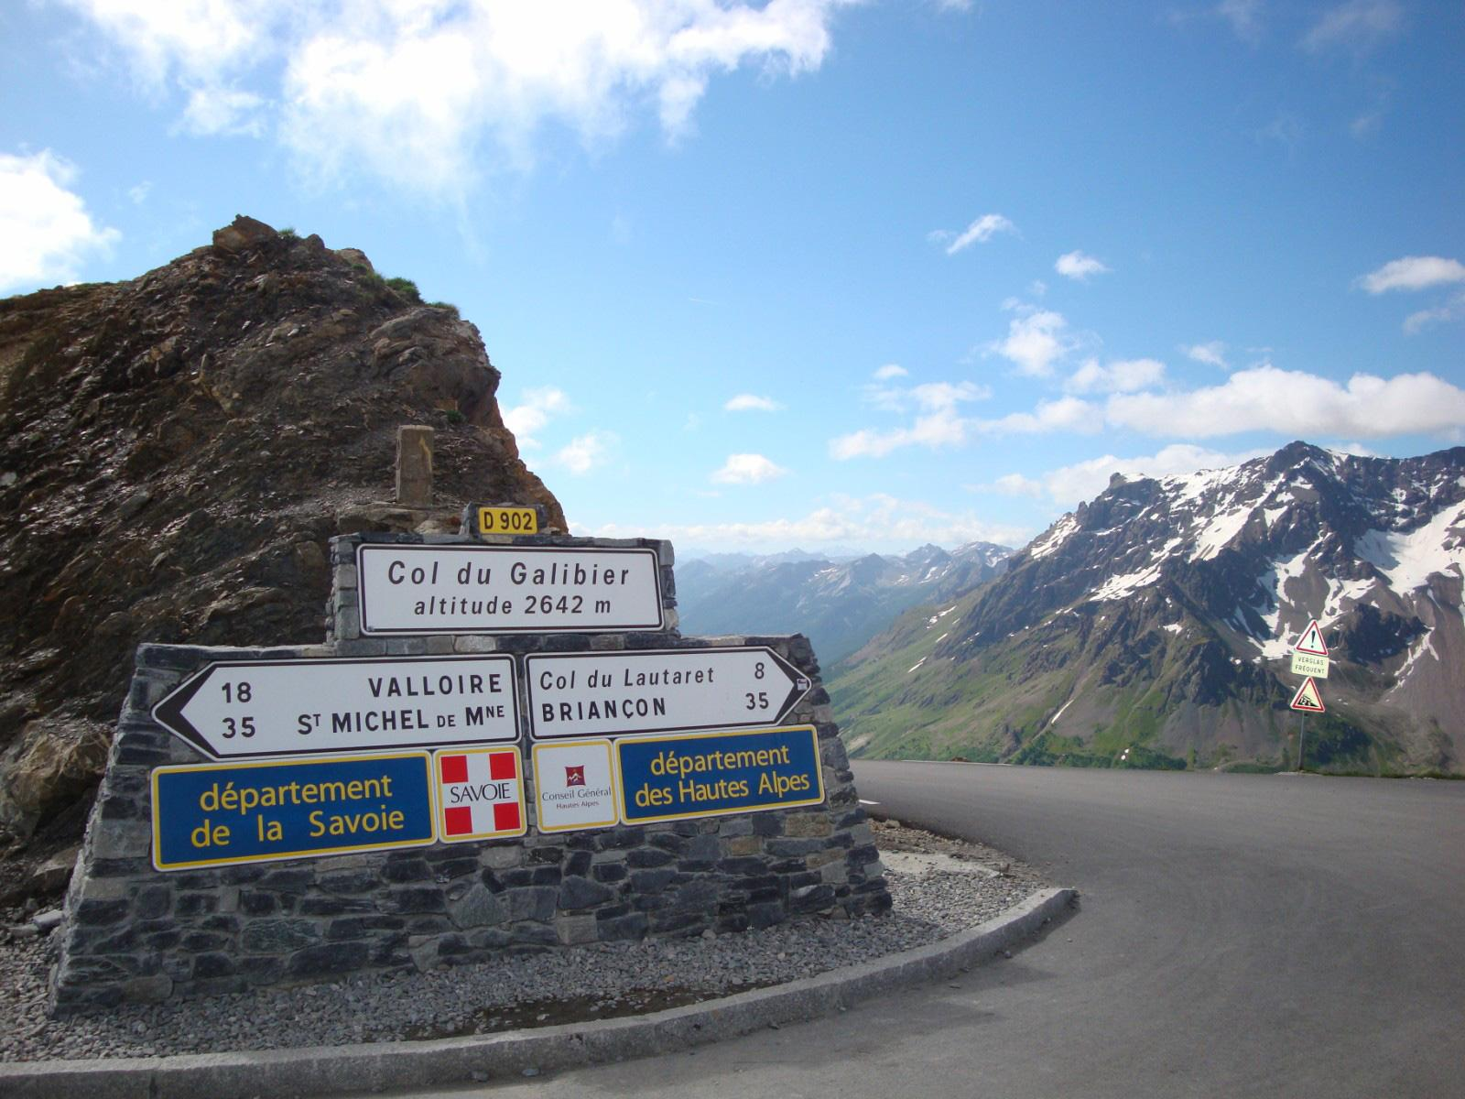

| (Need to organise RAID control carnet)  Accommodation - | | | | |
| --- | --- | --- | --- | --- |
| Tarcker link here | | | | |
| Route Info - Are the Cols open - <https://inforoute.ha-py.fr/#>  The Raid Alpine (Lake Geneva to Nice) is a classic road cycling challenge through the French Alps over some of the most legendary Alpine climbs, including two of the highest passes in the Alps, the Cime de la Bonette and the Col de l’Iseran. The scenery shifts dramatically from quintessential Alpine meadows in the north to magnificent rocky gorges and Mediterranean landscapes in the south. | | | | |
| Potential Logistics | **Van Hire UK (One-Way)**   * Hire small van from Enterprise: Leamington Spa → Dover: ~£100 * Drive to Dover, take ferry to Calais/Dunkirk   Two in Van and two others take train to Dover  **Hire van in Calais, drop in Thonon-les-Bains**   * Available from: Enterprise, Europcar, Hertz at Calais Ferry Terminal * One-way drop-off available to Thonon-les-Bains * Cost: Need to get quote (varies by company, dates, vehicle size)   Other option is to fly and Hire Bikes (faster option). Depending on bike rental options and flights it may be easier to fly to Nice, hire bikes and train back to Thonon-les-Bains to begin. Drop bikes back in Nice and fly from Nice.  Begin 2nd leg of Cheese and Wine Tour |  |  |  |

|  | **Start - Finish** | **Route Notes** | **Control Points** | **Comments** | **Where to Stay** |
| --- | --- | --- | --- | --- | --- |
| Day 0  /07/2026 | Transit to Thonon-les-Bains | GPX FIles |  |  |  |
| Day 1  01/07  110km / 2,550m | Thonon-les-Bains → La Clusaz | Warm up from Lake Geneva through pine forests.  **Cols:**  Col des Moises (1,118m)  Col de Terramont (1,080m)  Col de Jambaz (1,027m)  Col de la Ramaz (1,557m)  Col de la Colombiere (1,613m) |  |  |  |
| Day2  02/07    109km / 3,150m | La Clusaz → Sainte-Foy-Tarentaise | Through famous Alpine areas. 26km descent to Bourg-Saint-Maurice  **Cols:**  Col des Aravis (1,487m)  Col de Saisies (1,633m)  Col du Pré (1,740m  Cormet de Roselend (1,968m) |  |  |  |
| Day 3  03/07  129km / 3,060m | Sainte-Foy-Tarentaise → Valloire | The Iseran - 36km climb!  **Cols:**  Col de l'Iseran (2,770m)  Côte d'Aussois (1,519m)  Col du Télégraphe (1,566m) |  |  |  |
| Day 4  04/07  121km / 3,200m | Valloire → Vars | Legendary Tour de France climbs  **Cols:**  Col du Galibier (2,642m)  Col d'Izoard (2,361m)  Col de Vars (2,109m) |  |  |  |
| Day 5  05/07  134km / 3,400m | Vars → Valberg | Highest paved road in Europe!  **Cols:**  Col de Vars summit (2,105m)  Cime de la Bonette (2,802m)  Col de la Couillole (1,678m) |  |  |  |
| Day 6  06/07  160km / 2,000m | Valberg → Nice | Final day - scenery becomes Mediterranean<br><br>**Cols:**<br>- Gorges du Cian (descent)<br>- Col de Saint-Raphaël (876m)<br>- Col de Bleine (1,439m)<br>- Col du Pilon (786m)<br><br> |  |  |  |
| Day 7 | Transit Nice → Home |  |  |  |  |